Software Engineering Department

Braude College

Capstone Project Phase A

**Impact of subliminal perception on motor planning**

**25-2-D-1**

Students:

Daniel Shahar

Rachel Avidan-King

Mentors:

Dr. Anat Dahan

Dr. Marcos Hilsenrat

|  |
| --- |
|  |

Table of Contents

2 Abstract 3

3 Introduction 3

4 Background and Related Works 4

4.1 Introduction to Subliminal Perception 4

4.1.1 Commonly Used Terms 4

4.1.2 Subliminal perception 4

4.1.3 Threshold in perception 5

4.1.4 JND - and methods to measure 5

4.1.5 Priming in the context of subliminal perception 7

4.1.6 Priming and preferences 7

4.2 Introduction to Reaching Movement 9

4.2.1 Evaluating motor planning of reaching movement 9

4.2.2 Timed response paradigm 10

4.3 Subliminal Perception and Reaching Movements 12

5 Expected Achievements 13

5.1 Outcomes 13

5.2 Criteria for Success 13

6 The Process 14

6.1 Research – Subliminal Perception and Reaching Movements 14

6.2 Constraints and Challenges in Product Planning 15

6.3 Methodology and Development Process 16

7 Product 18

7.1 System Usage 18

7.2 The System Architecture 19

7.3 Pseudocode for JND Determination Algorithm 21

7.4 Prototypes of the Application GUI 22

8 Validation and Testing Plan 27

8.1 Evaluation 27

8.2 Validation and Testing Strategy 27

8.2.1 Android Application Testing 27

8.2.2 Data Analysis Testing 27

8.2.3 Results Visualization GUI Testing 28

9 References 30

# Abstract

The human brain constantly processes sensory information, much of which remains below conscious awareness, a phenomenon known as subliminal perception. While its influence on higher-order cognitive processes is well-documented, the impact of subliminal cues on motor actions, particularly fundamental reaching movements, is less understood. A significant challenge in this field is the consistent and precise delivery of subliminal stimuli, coupled with accurate measurement of subtle behavioral responses, due to limitations in traditional experimental setups.

To address this, our project proposes the development of a novel Android-based application designed to investigate the effects of subliminal color cues on reaching movements. This application will provide a controlled and standardized platform to accurately determine an individual's perceptual threshold and subsequently assess how visual information presented below that threshold influences their motor planning and execution.

We anticipate that this tool will facilitate the collection of high-quality kinematic data on movement initiation time, velocity profiles, and accuracy across various target presentation timings (subliminal, obvious, and synchronous with an auditory cue). Ultimately, this research aims to illuminate the temporal dynamics of motor planning and the potential for non-conscious visual information to prime or bias goal-directed reaching actions, thereby contributing significantly to our understanding of sensorimotor integration.

# Introduction

The human brain is a remarkable information processing system, constantly receiving and interpreting sensory data, much of which never reaches conscious awareness. This phenomenon of subliminal perception, where stimuli are presented below the threshold of conscious detection, has long captivated scientific inquiry due to its potential to subtly influence thoughts, emotions, and, crucially, behavior. While extensive research has explored the impact of subliminal cues on higher-order cognitive processes like preference formation or decision-making, their influence on motor actions, particularly fundamental tasks like reaching movements, remains an area less thoroughly investigated. Reaching, though seemingly simple, involves complex perceptual-motor integration, and understanding how non-conscious visual information might modulate its execution could reveal profound insights into the automaticity and flexibility of human action.

A significant challenge in the study of subliminal perception and its effects on behavior lies in accurately and consistently delivering stimuli below the conscious threshold, while simultaneously capturing precise behavioral responses. Traditional experimental setups often face limitations in controlling all variables or presenting stimuli with the exact temporal precision required for subliminal effects. Furthermore, objectively measuring subtle changes in motor control, such as those that might arise from unconscious cues, necessitates robust and replicable methodologies. The scarcity of readily available, highly controlled experimental tools capable of integrating precise subliminal stimulus presentation with accurate motor behavior recording presents a considerable hurdle for advancing this field of research.

To address these challenges, this project proposes the development of a novel Android-based application specifically designed to investigate the effects of subliminal color cues on reaching movements. This application offers a controlled, standardized platform to precisely determine an individual's perceptual threshold and then systematically assess how visual information presented below that threshold influences their motor planning and execution. By providing a streamlined and accessible experimental tool, we aim to facilitate the collection of high-quality, publishable data that can contribute significantly to our understanding of the fascinating and underexplored connection between non-conscious perception and goal-directed action.

# Background and Related Works

## Introduction to Subliminal Perception

### Commonly Used Terms

**Forced choice question:**

A forced-choice question requires respondents to select one option from a limited set, preventing neutral or undecided answers. By eliminating ambiguity, forced-choice questions can provide more definitive data for analysis.

**Different from chance:**

In an experiment, being different from chance means that the observed results are unlikely to have occurred randomly. Statistical tests help determine if the differences between experimental groups are significant, suggesting a real effect of the manipulation rather than just random variation.

### Subliminal perception

Subliminal perception is “perception without awareness” (Jem E. Berkes) - the point in which a human is unable to consciously differentiate between different sensory stimuli (of the same sort – i.e. touch vs. touch or vision vs. vision). The first documented research on this subject (Pierce and Jastrow's (1884)) – tested whether the participants of the experiment would notice which hand has more pressure put on it and were forced to choose between the options and how confident they were in that assessment. The surprising result was that even when the participant indicated they were unsure and therefore guessing which pressure was greater – they were still correct over 50% of the time – significantly different from chance.

According to Merikle and Joordens (1997) perception without awareness occurs when the subject of an experiment claims they can no longer notice the stimuli and yet there was still a noticeable effect of said stimuli upon a further choice. However, there has been considerable debate over how unconscious the perception truly is, since there is no clear empirical way to measure whether the stimuli are truly subliminal. The subject themselves must indicate when they believe they no longer perceive a difference, and that is a subjective measurement in and of itself.

### Threshold in perception

Building upon the challenges in defining 'awareness,' determining a participant's threshold for a given stimulus also presents a significant difficulty in the study of subliminal perception. The term threshold, also referred to as limen, is a central concept in the study of subliminal perception. “Subliminal perception occurs whenever stimuli presented below the threshold or limen for awareness are found to influence thoughts, feelings, or actions” (Merikle, 2000).

There is a difficulty in determining a participant’s threshold to a given stimuli which creates a difficulty in the study of subliminal perception. However, the nature of the threshold used is essential for identifying subliminal perception because a stimulus is only considered subliminal when it is below the threshold of awareness.

Cheesman and Merikle (1985) have called the subjective threshold: "the detection level where subjects claim not to be able to discriminate perceptual information at better than chance level" (i.e. the subject of the experiment determines when they can no longer perceive the difference). The objective threshold, "the level of detectability where perceptual information is actually discriminated at chance level" (i.e. every subject of the experiment is given the same discrete options to choose from).

The choice of subjective threshold or objective threshold in an experiment affects the conclusions of a subliminal perception study.

### JND - and methods to measure

The JND, Just Noticeable Difference or difference threshold, is the smallest change in a sensory stimulus that a person can detect. Gustav Fechner (Fechner, 1860), a pioneer in psychophysics, suggested that the JND is a psychological unit, representing the minimum detectable change in sensation. However, it's not quite that simple. Gösta Ekman (Ekman, 1956) later showed that the JND is not constant. Instead, it varies with the intensity of the stimulus, often following a power or linear function. This means the ability to perceive a difference is relative, not absolute.

A good example would be perceiving different hues: to measure the JND for hue, an experiment would systematically change the wavelength of light and ask participants when they notice a change in color. This would quantify the minimum wavelength change needed for a perceived difference.

Importantly, the JND isn't fixed. It changes depending on the type of stimulus, individual differences, and even viewing conditions. For instance, sensitivity to wavelength changes (and thus the JND for hue) varies across the color spectrum and between foveal and peripheral vision. This variability highlights the complexity of sensory perception and the need to consider context when studying subliminal effects.

In the following examples, the ratio between the RGB is such: all rectangles have the same red (9) and green (22) values, with the blue being the only difference.



Figure : In the above picture the left rectangle has blue (140) and right has blue (141)

Figure : In the above picture the left rectangle has blue (140) and right has blue (150)



Figure : In the above picture the left rectangle has blue (140) and right has blue (200)

Some participants of the experiment would be able to choose correctly which is brighter in figure 2, and others would be unable to choose correctly in figure 2. Theoretically, more participants would be able to choose correctly in figure 3, than in figure 2, and more participants would be able to choose correctly in figure 2 than in figure 1. However, if instead of changing the blue ratio, the red ration was the parameter changed, the same test subjects would also have different personal JNDs.

### Priming in the context of subliminal perception

Subliminal perception, particularly when investigated through priming paradigms, provides compelling evidence for how stimuli presented below the threshold of conscious awareness can influence subsequent responses. Priming refers to the phenomenon where exposure to a 'prime' stimulus affects the processing of a subsequent 'target' stimulus.

A notable study by Debner and Jacoby (1994) utilized an 'exclusion paradigm' to explore this effect. In their word completion task, participants were instructed to avoid using previously presented priming words when completing word stems. Intriguingly, when the priming words were presented subliminally, participants were observed to use them more frequently in the word completion task, compared to instances where the primes were consciously perceived.

This counterintuitive result highlights a key distinction between conscious and unconscious perception. When conscious awareness is involved, participants can deliberately avoid using the prime. However, subliminal primes bypass this conscious control, leading to a stronger influence on behavior. As Debner and Jacoby (1994) concluded, “In each of these experiments, unambiguous evidence of the existence of unconscious perception was provided by an exclusion test condition. Such evidence cannot be explained as truly resulting from conscious perception because conscious perception would produce an opposite result.” This suggests that unconscious processing can exert a distinct and powerful influence on behavior, separate from conscious control.

### Priming and preferences

The experiment conducted by Kunst-Wilson and Zajonc (1980) explored the question of whether individuals can develop preferences for stimuli to which they have been previously exposed, even in the absence of conscious recognition. This inquiry challenges the traditional assumption that the development of liking is contingent upon conscious recognition and understanding.

The experiment had two main phases:

Exposure Phase: Subjects were briefly shown some novel images (in the study, these were irregular octagons) under conditions so poor (very short flashes and low light) that they couldn't consciously see or remember them. This was done to create unconscious exposure to these images.

Test Phase: Later, the same subjects were shown pairs of images. Each pair contained one image they had been briefly exposed to earlier (an "old" image) and one completely new image. They were asked two things: which image they liked better (affective judgment) and which image they thought they had seen before (recognition judgment).

The principal finding of the study was a significant dissociation between preference and recognition. As the authors stated: “The results revealed clear preferences for exposed stimuli, even though subjects in a recognition memory test could not discriminate them from novel stimuli.”

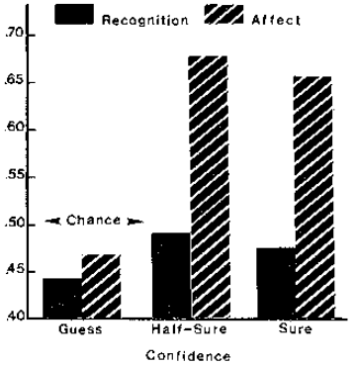

Figure : The results of the Kunst-Wilson and Zajonc (1980) experiment, as graphed by the authors.

Although the study is primarily known for demonstrating affective discrimination without recognition and the mere-exposure effect under subliminal conditions, the mechanism of a prior, unrecognized stimulus influencing a later judgment aligns conceptually with the idea of unconscious priming. The initial brief exposure "primed" a positive affective response towards those stimuli in the subsequent preference task, even without conscious recognition of the prior exposure.

## Introduction to Reaching Movement

### Evaluating motor planning of reaching movement

Reaching movements, a specific type of motor activity, involves moving the hand (or a tool held in the hand) from an initial position to a target location in space. According to Dahan, Bennet, and Reiner (2019), "Object reaching movements consist of two problems: choosing the target of the movement and defining a motor plan for the movement." This motor plan dictates the parameters of the movement, including direction, extent, and trajectory, and is established prior to movement initiation. Factors such as target complexity, the presence of obstacles, and the available preparation time can influence this planning process, often necessitating online adjustments.

Evaluating motor planning in reaching movements can be achieved through behavioral and neurophysiological approaches. A key behavioral method involves manipulating the time allowed for planning before the initiation of a reach and then analyzing the resulting movement characteristics.

When participants are given sufficient planning time, they are expected to formulate a complete motor plan, leading to an immediate initiation of the movement upon a 'GO' cue. This is often characterized by a smooth, unimodal, and bell-shaped velocity profile. Conversely, when planning time is limited, participants may exhibit a delayed movement onset, suggesting they required additional time to finalize their motor plan. The velocity profile might also be less smooth and display multiple peaks, indicating online corrections due to an incomplete initial plan. As Dhan and Reiner (2017) note, "When planning time is not sufficient, they start the movement in a delayed time, possibly indicating that they needed to complete a movement plan."

By analyzing kinematic parameters such as reaction time (the duration between the 'GO' signal and the initiation of movement, reflecting the time needed to process the cue and begin motor execution), velocity profile characteristics (the pattern of movement speed over time, where the shape indicates the smoothness and efficiency of the movement, the number of peaks can suggest online corrections or hesitations, and symmetry reflects the coordination of acceleration and deceleration phases), and movement duration (the total time taken to complete the reach, indicating the overall speed and efficiency of the executed plan) across varying preparatory intervals, researchers can infer the quality and efficiency of motor planning. Shorter reaction times and a more symmetrical, unimodal bell-shaped velocity profile, coupled with appropriate movement duration under longer planning conditions, are typically associated with improved motor planning.

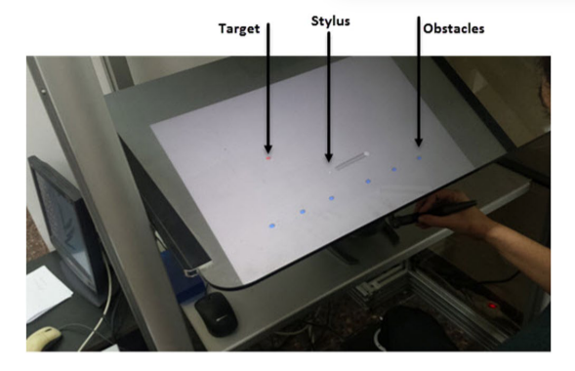

Figure : A reaching movement task, with the red dot as a target and the blue dots as obstacles.

### Timed response paradigm

The timed response paradigm was an experimental procedure introduced by Hening, Favilla and Ghez in 1988 designed to isolate and examine the temporal dynamics of motor planning, particularly in reaching movements. This paradigm offers precise experimental control over the time between target presentation and response initiation. As Hening, Favilla, and Ghez (1988) articulated, “The major benefit of the timed response paradigm is that by using a predictable tone to determine the timing of response initiation we can make latency or S—-R interval an independent variable under experimental control” Key characteristics include:

* **Auditory Synchronization:** Participants synchronize their motor response with a predictable auditory stimulus, typically the final tone in a sequence. This auditory cue serves as the 'GO' signal.
* **Stimulus Dissociation:** Unlike standard reaction time tasks, the timed response paradigm separates the target information (visual) from the response trigger (auditory). The visual target specifies the response parameters (e.g., amplitude, direction), while the auditory cue dictates the response timing.
* **Controlled Stimulus-Response Interval (S-R Interval):** Researchers systematically manipulate the S-R interval, the time between the visual target and the auditory cue. This manipulation enables research of motor responses across various time periods, including those shorter and longer than typical reaction times.
* **Uncorrected Motor Impulses:** Participants typically produce a single, uncorrected motor impulse in response to the target. This constraint allows for a focused analysis of the initial motor program and its sensitivity to available processing time.

The timed response paradigm, therefore, provides a controlled environment for examining the temporal evolution of motor planning, allowing researchers to explore how varying preparatory intervals influence the specification and execution of reaching movements and was used by both Dhan and Reiner (2017) and Dhan, Bennet, and Reiner (2019).

Consider the experimental design employed by Dhan and Reiner (2017), adapted from the foundational timed response paradigm of Hening et al. (1988). Their methodology involved training participants to generate isometric elbow force impulses synchronized with the final tone of a sequence. Crucially, a visual target specifying movement direction and amplitude was presented at either a short (25 milliseconds) or a long (350 milliseconds) interval before the 'GO' cue. This paradigm offers a robust framework for investigating motor planning. For instance, one could replicate this core design with minor variations, such as manipulating the complexity of the visual target (e.g., increasing the number of potential target locations), altering the duration of the short and long S-R intervals, or even introducing subliminal cues during the preparatory period to examine their potential influence on subsequent motor output. The controlled nature of the timed response, as exemplified in this study, allows for systematic exploration of factors affecting the temporal dynamics of motor planning and the potential interplay with subliminal perception.

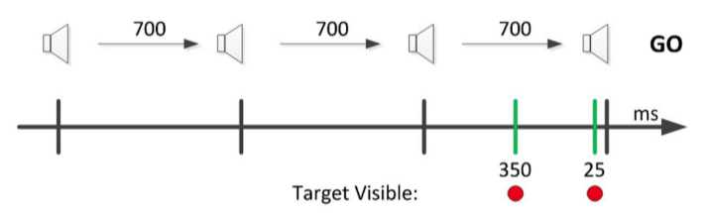

Figure : The black lines signify the four tones with 700 milliseconds difference between each one and the green lines signify the two possible visual target queues (at 350 milliseconds or 25 milliseconds).

## Subliminal Perception and Reaching Movements

Subliminal perception can significantly influence reaching movements, impacting both their initiation and subsequent online control. Research consistently indicates that even without conscious awareness, individuals can process visual information that ultimately triggers or modulates motor responses. A prominent 2012 study by Leukel, Lundbye-Jensen, Christensen, Gollhofer, and Nielsen demonstrated that "Subconscious processing has been shown to be capable of triggering motor reactions" (Leukel et al., 2012), either by enabling correct motor responses or by interfering with motor planning and execution.

Specifically, subconscious visual information was found to be sufficient to trigger appropriate motor responses in a choice reaction task. Even when individuals were not consciously aware of a visual cue's content, they could still make correct motor choices. An individualized analysis further confirmed this: when subjects were unable to consciously perceive the visual cue (responding correctly at or below pure guessing levels, 50% or less, in verbalization trials), their probability of making correct motor responses to identical cues during a reaching movement was significantly enhanced. The study utilized a "neutral mask" that did not contain the crucial information for the motor response, ensuring that the subconscious target cue alone was responsible for guiding the correct action (continuing or stopping a reaching movement). As the authors concluded, "The results demonstrate that subjects could perform the correct motor action (go and stop trials) without being consciously aware" (Leukel et al., 2012). This finding contrasts with previous studies where conscious and subconscious stimuli might have shared information, only facilitating a response.

Beyond the initiation of movements, subliminal perception has also been shown to influence the control of an already-initiated goal-directed pointing movement. A different study by Cressman, Franks, Enns, and Chua (2006) emphasized this, stating, "The novel contribution of this study is that it showed the influence of invisible primes for ongoing goal directed actions, rather than merely in the initiation of these actions." Masked primes were observed to influence pointing trajectories remarkably quickly, with effects occurring sooner than deviations seen in response to visible masks. Initial deviations in movement trajectories from the central target were consistently in the direction cued by the prime, regardless of the direction indicated by the subsequent visible mask.

This rapid influence had practical implications for movement execution. Congruent primes (where the prime and mask cued the same direction) allowed for earlier modifications to the correct eccentric target, effectively giving the pointing modification a "head start." In contrast, incongruent primes (where the prime cued a different direction than the mask) resulted in initial trajectory deviations towards the wrong target. This required additional movement time for participants to correct their movement, with trajectories being directed to the correct target only after participants reacted to the mask. This swift incorporation of new visual information into the control of the pointing action, even when subliminal, suggests an automatic influence. As Cressman et al. (2006) highlighted, "The main evidence for this was that initial deviations in movement trajectories from the center target were always in the direction cued by the prime, regardless of the direction of the subsequent mask." Collectively, these findings demonstrate that subliminal visual cues can exert a direct and automatic impact on both the initiation and ongoing execution of goal-directed reaching movements.

# Expected Achievements

## Outcomes

The primary outcomes we anticipate from this project center on understanding how subliminal and consciously perceived cues influence reaching movements towards visual targets. By meticulously measuring participants' initial color perception thresholds, we aim to establish a baseline for individual sensory processing. Subsequently, through the reaching experiment involving varied target presentation timings – subliminal, obvious, and synchronous with an auditory cue – we expect to gather detailed kinematic data on movement initiation time, velocity profiles, and accuracy.

Our analysis will focus on identifying whether the subliminal presentation of the target 350 milliseconds prior to the fourth tone leads to earlier movement initiation or altered trajectory compared to the other conditions. Furthermore, we intend to explore the extent to which the obvious pre-cue and the synchronous cue affect the reaching movement.

Ultimately, this research seeks to shed light on the temporal dynamics of motor planning and the potential for subliminal visual information to prime or bias reaching actions, contributing to a deeper understanding of sensorimotor integration.

## Criteria for Success

1. **Accurate Measurement of Color Thresholds:** Successfully develop and implement the color discrimination task to reliably determine individual user thresholds.
2. **Effective Subliminal and Supraliminal Cue Presentation:** Implement the timed visual cue presentation (subliminal, obvious, and synchronous) with the required 350-millisecond precision.
3. **Precise Tracking of Reaching Movements:** Accurately record and store kinematic data (e.g., initiation time, velocity, trajectory) of the users' reaching movements in the experimental task.
4. **Demonstrable Influence of Subliminal Cues:** Identify statistically significant differences in reaching movement parameters (e.g., reaction time, initial direction) when a subliminal target is presented compared to conditions without a pre-cue or with an obvious pre-cue.
5. **Clear Data Analysis and Visualization:** Develop methods to effectively analyze the collected kinematic data and present the findings in a clear and understandable format (e.g., graphs, tables).
6. **Functional Android Application:** Create a stable and user-friendly Android application that seamlessly guides users through the color threshold task and the reaching experiment.

# The Process

The information gathering and learning process for this project was divided into two main areas: theoretical knowledge regarding subliminal perception and reaching movements, and the practical considerations of designing and implementing a system to investigate their interaction.

## Research – Subliminal Perception and Reaching Movements

To broaden our understanding of subliminal perception and reaching movements, we focused on answering the following key questions:

* What is subliminal perception? How can it be measured and observed? What is the threshold in the context of subliminal perceptions, and what constitutes a just noticeable difference (JND)?
* What is priming and how does it relate to subliminal perception? Does preference play a role in how subliminal stimuli are perceived?
* What is motor planning and how does it relate to reaching movements? What are the common paradigms used to study reaching movements?
* How can reaching movements be affected by subliminal perception? What previous experiments have been conducted to investigate this relationship?

To address these questions and expand our knowledge, we consulted various resources, primarily focusing on published scientific articles and academic books. After reviewing the available literature, we held a brainstorming session to determine the optimal approach for our application. We concluded that the most effective way to test the impact of subliminal perception on reaching movements would be to identify each participant's JND and perceptual threshold for a specific color. This approach would allow us to isolate the effect of subliminal color stimuli on reaching movements, rather than relying on priming effects or focusing on JND for patterns.

## Constraints and Challenges in Product Planning

Developing the actual application presented several practical challenges, particularly in devising a robust method for determining a participant's perceptual threshold. We conducted various demo tests using PowerPoint presentations to refine our approach.

Our initial method involved displaying two side-by-side color patches, labeled A and B, where one was always a reference color (blue with hue 140, 9 red, 22 green). The second patch had a clearly different hue (e.g., 175 blue vs. 140 blue, with red and green values consistent). Participants were then asked: "Which is brighter, A or B?"

During these demo tests, several issues arose regarding the presentation of these color patches:

* **Size of Color Patches:** We experimented with different sizes for the rectangular color patches on the page.
* **Static vs. Dynamic Placement:** We observed that when the color patches remained in the same spot across slides, participants could sometimes detect a change between slides without consciously perceiving a color difference. To mitigate this, we eventually settled on inserting a blank slide between each actual question, while keeping the colored rectangles in a consistent position. This provided a necessary visual break, preventing participants from anticipating changes based on spatial memory.
* **Presentation Order of Opposing Hues:** We tested various sequences for presenting the opposing blue hues (175, 165, 160, 155, 150, 145, 144, 143, 142, and 141 blue) against the 140 blue reference. We explored:
  + **Completely random placement:** Where any opposing hue could appear after any other.
  + **Rising order:** Progressing from the most perceptually different hue (175) down to the least (141).
  + **Random with an offset:** Where the presentation was random but avoided immediate transitions between very different and very similar hues (e.g., 141 blue vs. 140 blue would not immediately follow 175 blue vs. 140 blue).

Through these demo tests, involving around ten different versions and participant trials, we determined that the random presentation yielded the most reliable results for accurately measuring participants' thresholds.

Finally, in terms of implementation, we researched various programming languages for developing an Android application and ultimately decided that Kotlin was the most suitable option, preferring it over alternatives like Unity. The final experiment will be conducted on a consistent Android tablet provided by our supervisor.

## Methodology and Development Process

For the development of our application, we adopted the Agile methodology, which we found highly suitable for our project's scope. This iterative approach allows us to break down feature delivery into smaller, manageable components, providing maximum flexibility for incorporating changes and feedback. Our development process will be structured into the following iterations:

1. **Threshold Determination - GUI and Database:** Design and implement the Graphical User Interface (GUI) for the threshold finding task and establish the associated database for data storage.
2. **Threshold Determination - Logic and Validation:** Develop the forced-choice logic for the threshold task, integrate randomness tests to ensure unbiased stimulus presentation, and connect these functionalities to the database. This iteration will include thorough verification that all components are fully operational.
3. **Personal Information Input - GUI and Database:** Create the GUI for collecting participant personal information, including the welcome page, and connect this to the database. Verification will ensure seamless data flow.
4. **Reaching Movement Experiment - Obvious Differences:** Construct the first two of our three reaching movement experiments. These experiments will focus on scenarios with obvious color differences presented at 0 milliseconds and 350 milliseconds before the fourth auditory beep.
5. **Reaching Movement Experiment - Subliminal Differences:** Develop the third experiment, which will specifically test reaching movements under subliminal color differences. This will involve connecting the experiment to the database and verifying its complete functionality.
6. **Results Analysis - GUI and Database:** Create the GUI for analyzing and displaying the experimental results, ensuring proper connection and data retrieval from the database. Full functionality verification will be performed.

Throughout this process, an evaluation will be conducted after each iteration. Any necessary adjustments identified during these evaluations will be implemented before commencing the subsequent development cycle. Our primary focus is on delivering a robust, working software that effectively incorporates feedback from users testing our product.

# Product

This mobile application, developed for the Android platform, will serve as a data acquisition and data analysis tool for research investigating the impact of subliminal perception on reaching movements. The participants will input personal information, and then the application will present participants with three distinct experimental modules: The first module, a personalized threshold assessment, will employ a two-alternative forced choice paradigm. Participants will be presented with 100 individual trials, each displaying a pair of blue squares differing subtly in hue across ten incremental levels. This adaptive testing procedure aims to determine the individual's perceptual threshold for discriminating between these hues. The second module will involve a visuomotor task. Participants will be presented with a display containing four potential targets and several distractor elements. Following four auditory cues, participants will be instructed to perform a rapid swipe gesture from the center of the screen towards a designated target. This task will be repeated ten times, with the visual cue for the target appearing either 350 milliseconds prior to the fourth auditory cue at a hue difference below the participant's previously established discrimination threshold, 350 milliseconds prior at a suprathreshold hue difference, or concurrently with the fourth auditory cue at a suprathreshold hue difference. Finally, the third module will provide the researchers with the ability to choose which data will be analyzed and displayed according to the participants personal information.

## System Usage

The following Use Case diagram shows how every participant of the experiment will be able to input their personal information (personal data which will be relevant to analyze the results). The participant will also be able to identify their personal threshold and to then test their reaching movements. The researchers will be able to do all the above and additionally, will be able to ask the system to analyze the results and export them as a file.

Figure 7: Use Case Diagram

Functional Requirements

|  |  |
| --- | --- |
| 1 | The system offers users the option to input personal information. |
| 2 | The system offers users the option to identify their personal threshold. |
| 3 | The system offers users the option to participate in the experiment and test reaching movement. |
| 4 | The system offers researcher’s the option to see analyzed data. |
| 5 | The system allows to exit the experiment at all times. |

Non-Functional Requirements

|  |  |
| --- | --- |
| 1 | The system will work on an Android OS. |
| 2 | The system will use a touch screen. |
| 3 | The system will keep data of the experiment. |
| 4 | The system will analyze the data and create graphs. |
| 5 | The system will be able to export the data. |

## The System Architecture

The following Activity diagram shows the flow of activities within the system. A participant of the experiment must first input their personal information: Age, gender, time of the test and if there are known eye issues (such as glasses). Apon finishing with providing said information, the participants can then proceed to identify their personal threshold and then to test their reaching movements. The researcher will be able to use the application to analyze the data and may even filter the data according to the participants personal information in order to see different graphs for different age ranges, genders and the like.

The following diagram will help understand the different components of our system, before we show how they will actually interact with each other:

Figure 8: Activity Diagram

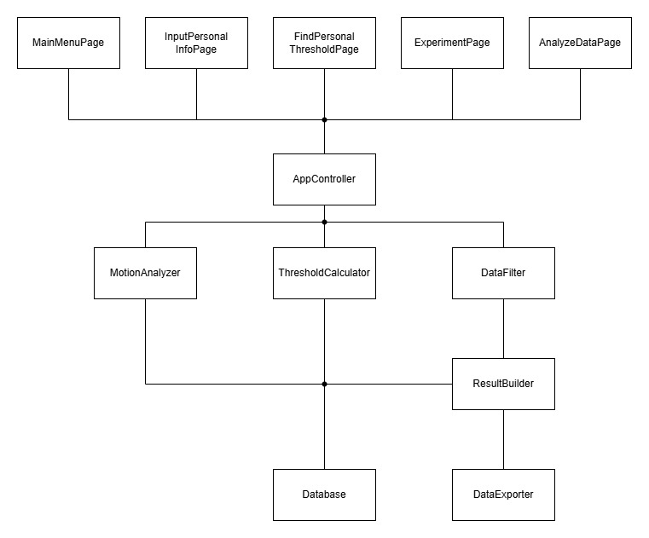

Figure 9 - System Components

The following sequence diagram will help visualize the interaction between the different objects in the system:

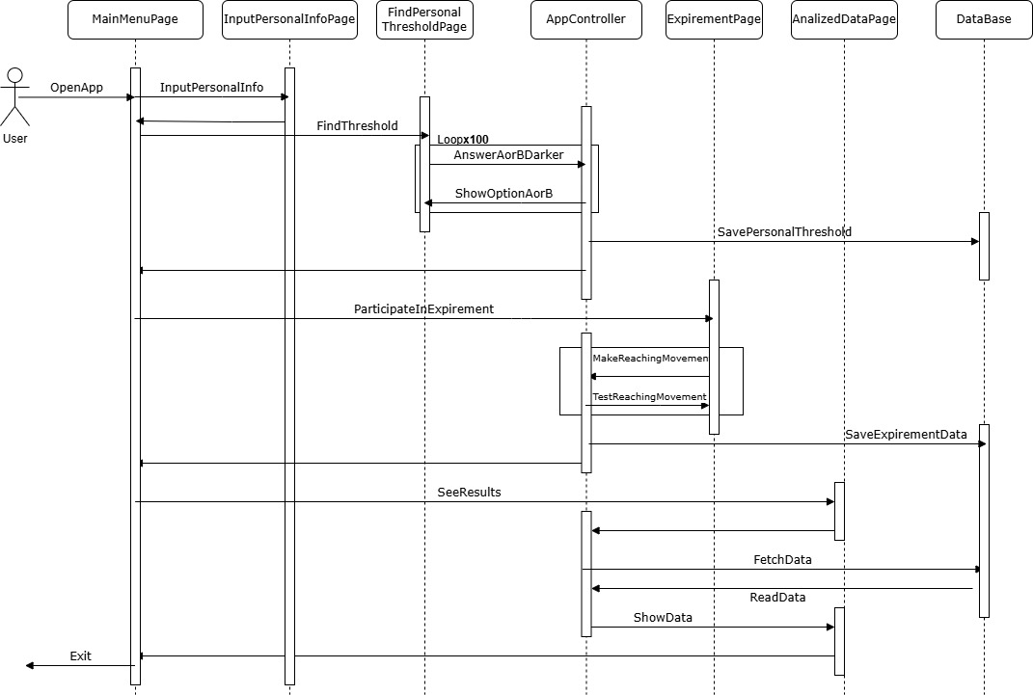

Figure 10: Sequence Diagram

## Pseudocode for JND Determination Algorithm

This algorithm aims to find a participant's Just Noticeable Difference (JND) for color perception by comparing a reference hue (n_0​) to a set of ten other hues. A total of 100 questions will be presented.

**FindJND_Adaptive()**

1. Initialize:
2. N_TOTAL ← 100
3. n₀ ← 140
4. HUES ← [141, 142, 143, 144, 145, 150, 155, 160, 165, 175]
5. MAX_PER_HUE ← 10
6. MAX_LEFT ← 5
7. trial_count ← 0
8. For each hue in HUES:
9. occurrences[hue] ← 0
10. left_count[hue] ← 0
11. correct_answers[hue] ← 0
12. While trial_count < N_TOTAL do:
13. valid_hues ← []
14. For each hue in HUES:
15. if occurrences[hue] < MAX_PER_HUE:
16. Append hue to valid_hues
17. if valid_hues is empty:
18. exit loop
19. selected_hue ← RandomChoice(valid_hues)
20. if left_count[selected_hue] < MAX_LEFT and RandomBoolean() = true:
21. position ← "left"
22. left_count[selected_hue] ← left_count[selected_hue] + 1
23. else:
24. position ← "right"
25. occurrences[selected_hue] ← occurrences[selected_hue] + 1
26. if position = "left":
27. Display PatchA ← selected_hue, PatchB ← n₀
28. correct_answer ← "A"
29. else:
30. Display PatchA ← n₀, PatchB ← selected_hue
31. correct_answer ← "B"
32. response ← GetUserResponse()
33. if response = correct_answer:
34. correct_answers[selected_hue] ← correct_answers[selected_hue]
35. trial_count ← trial_count + 1
36. return correct_answers

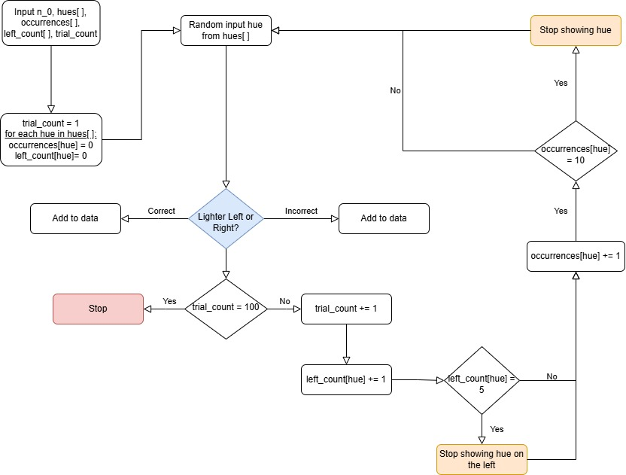

Figure – Flow Chart to explain the algorithm

## Prototypes of the Application GUI

The participant of the experiment will be handed a tablet by the researcher, and in the first page, they will see:

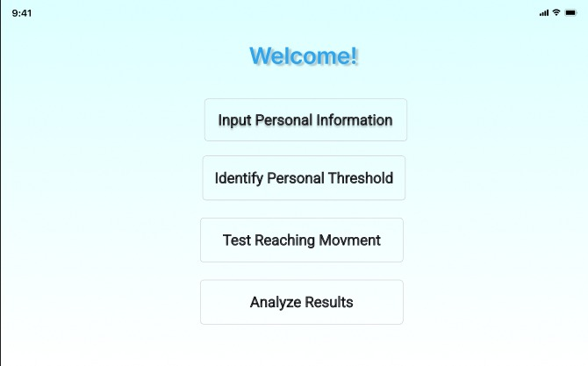

Figure – Main Menu

The first step the participants will have to do for our experiment is to input their personal information. This will be relevant so we can analyze the data using different criteria, including age or gender.

Figure – Participant will input personal information

In the second part of the experiment, the participant will find their personal threshold, using a forced choice question, forcing them to choose which is brighter, rectangle A or rectangle B.

Figure – An example of a test to find personal threshold – A is brighter

Figure – An example of a test to find personal threshold – B is brighter

In the third part of the experiment, we will test the participants reaching movement, and they will see four possible targets they will have to move their stylus to upon the sound of the fourth beep.

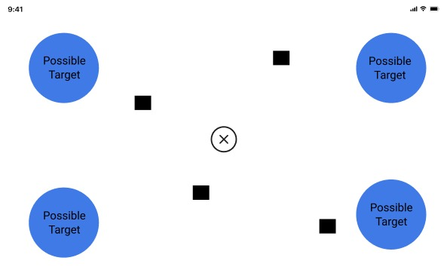

Figure – The four possible targets of the experiment

Figure – A target as will be seen in the experiment, with an obvious color hue difference (could be shown 350 or 0 milliseconds before fourth beep)

After each participant finished the experiment, their data will be saved for farther analysis. Our system will analyze the data, and the researcher will be able to see various graphs, like the velocity of different participant’s movement, as seen in the picture below. The more data acquired, the better the possibility that the researcher’s will see the correlation between the subliminal perception/ suprathreshold and the reaching movement.

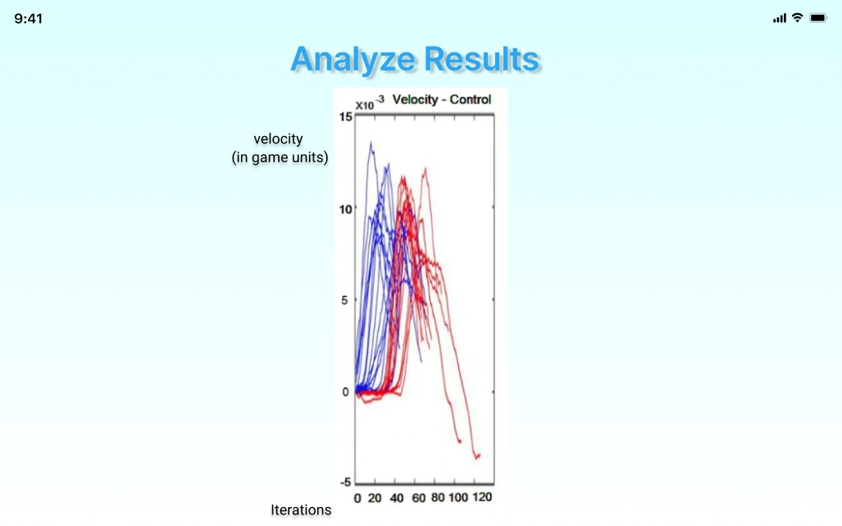

Figure – An example of some data analysis. The blue on the graph indicated when the participant was given 350 milliseconds before the fourth beep. The red was when the participant wasn't given any extra time before the fourth beep.

# Validation and Testing Plan

## Evaluation

Our product will be evaluated based on its capacity to accurately determine a participant's perceptual threshold and measure the effects of subliminal stimuli on reaching movements. Our primary goal is to provide a reliable tool for researchers investigating the subtle influences of subliminal perception on motor behavior. If our application consistently demonstrates the ability to establish a participant's JND and threshold, and if the reaching movement data collected aligns with established theories or previous findings in the field, this will indicate the accuracy and validity of our results.

## Validation and Testing Strategy

Our iterative development approach necessitates a comprehensive validation and testing strategy across all modules: the Android Application, the Data Analysis component, and the Results Visualization GUI. This strategy is designed to ensure both the technical robustness of our system and its effectiveness in serving our research objectives.

### Android Application Testing

Testing for the Android application will involve both automated unit tests using the Kotlin Test Framework and targeted manual quality assurance. This dual approach allows us to confirm the precise functionality of core features—such as accurate stimulus presentation, responsive user input handling, and reliable data capture and storage—while also subjectively evaluating the overall user experience, performance stability (e.g., framerate, load times), and the visual fidelity of color rendering and transitions.

### Data Analysis Testing

For the data analysis component, the focus is on computational accuracy and data integrity. We'll rigorously test to ensure that the raw data sets are correctly processed and formatted. Crucially, we'll validate the precision of our algorithms for calculating JNDs and perceptual thresholds, as well as the accuracy of metrics derived from reaching movement data (e.g., reaction times, movement kinematics).

### Results Visualization GUI Testing

The Results Visualization GUI will undergo thorough testing to ensure data representation accuracy and usability. This includes verifying fast and seamless navigation within the interface. We'll confirm that all charts, summaries, and tabular data are accurately and clearly displayed, reflecting the underlying experimental results. Furthermore, we'll validate the functionality for generating custom reports and the reliable retrieval of data from the central database.

|  |  |  |  |
| --- | --- | --- | --- |
| **Test No.** | **Module** | **Tested Function** | **Expected Result** |
| **1** | Android Application | Application Loading | Fast application load (< 3 seconds) |
| **2** | Android Application | Stable Framerate | Consistent framerate (at least 30fps) |
| **3** | Android Application | Scene Transitions | Smooth and fast transitions (< 2 seconds) |
| **4** | Android Application | Accurate Stimulus Presentation | No delays or mismatches in stimulus display |
| **5** | Android Application | Correct Color Rendering | Colors displayed accurately as defined (RGB values) |
| **6** | Android Application | User Input Handling | Application handles all user inputs as expected |
| **7** | Android Application | Data Storage | Correct and secure storage of all collected data |
| **8** | Data Analysis | Receive Correct Data Sets | Data sets received in correct format (e.g., {JND, Threshold, Reaching Time}) |
| **9** | Data Analysis | Threshold Calculation Accuracy | Calculated JND and Threshold align with known inputs |
| **10** | Data Analysis | Reaching Movement Metric Calculation | Accurate calculation of reaching times and deviations |
| **11** | Results GUI | Page Load | Fast page load (< 2 seconds) |
| **12** | Results GUI | Navigation | Smooth and fast page navigation |
| **13** | Results GUI | UI/UX | User-friendly and intuitive interface |
| **14** | Results GUI | Data Visualization | Correct display of charts, summaries, and raw data |
| **15** | Results GUI | Report Generation | Accurate generation of reports based on user selection |
| **16** | Results GUI | Data Fetching from Database | Correct retrieval of data from the database |

# References

* Berkes, J. E. (2004, December). *Does “subliminal perception” (perception without awareness) occur, and how can it be measured?* (Course 17.361). University of Manitoba.
* Cheesman, J., & Merikle, P. M. (1985). Priming with and without awareness. *Perception & Psychophysics*, *37*(4), 387–395.
* Cressman, E. K., Franks, I. M., Enns, J. T., & Chua, R. (2006). The influence of invisible shapes on the control of goal-directed pointing movements. *Experimental Brain Research*, *173*(3), 481–492.
* Debner, S. C., & Jacoby, L. L. (1994). Unconscious influences of memory: Dissociations between implicit and explicit expression. *Journal of Experimental Psychology: General*, *123*(4), 331–354.
* Dhan, A., Bennet, K. E., & Reiner, M. (2019). Object-reaching movements: The impact of target location and movement extent on motor planning. *Experimental Brain Research*, *237*(10), 2533–2545.
* Dhan, A., & Reiner, M. (2017). The effect of planning time on the velocity profile of reaching movements. *Experimental Brain Research*, *235*(11), 3373–3383.
* Ekman, G. (1956). Discriminal sensitivity on the subjective continuum. *Acta Psychologica*, *12*, 233–243.
* Fechner, G. T. (1860). *Elemente der Psychophysik*. Breitkopf und Härtel.
* Hening, W. A., Favilla, M., & Ghez, C. (1988). Timing of motor responses in a precued reaching task. I. Descriptive analysis. *Experimental Brain Research*, *71*(2), 336–350.
* Leukel, C., Lundbye-Jensen, J., Christensen, M. S., Gollhofer, A., & Nielsen, J. B. (2012). Subconscious visual information is sufficient to trigger appropriate motor responses in a choice reaction task. *PLoS One*, *7*(12), e51080.
* Merikle, P. M. (2000). Subliminal perception: Always unconscious processing? In M. S. Gazzaniga (Ed.), *The new cognitive neurosciences* (2nd ed., pp. 1151–1158). MIT Press.
* Merikle, P. M., & Joordens, S. (1997). Measuring unconscious influences. In J. D. Cohen & J. W. Schooler (Eds.), *Scientific approaches to consciousness* (pp. 401–418). Lawrence Erlbaum Associates Publishers.
* Pierce, C. S., & Jastrow, J. (1884). On small differences of sensation. *Memoirs of the National Academy of Sciences*, *3*, 75–83

**AI Conversations:**

* Notebook LM: <https://notebooklm.google.com/notebook/1d5d2392-c0e9-43fd-9eb4-14f645e2f9c1>
* JND: <https://gemini.google.com/app/40d73a850abdd0a8>
* Priming: <https://gemini.google.com/app/3673bb0f14ef4116>
* Reaching movement: <https://gemini.google.com/app/8080e9bea50bf1ef>
* Timed response paradigm: <https://gemini.google.com/app/ef8078cfd3628660>
* Subliminal perception and reaching movement: <https://gemini.google.com/app/666c3b9b3720aecf>

**GitHub Repository for the project:**  
<https://github.com/RachelAvidanKing/Capstone-Project/>